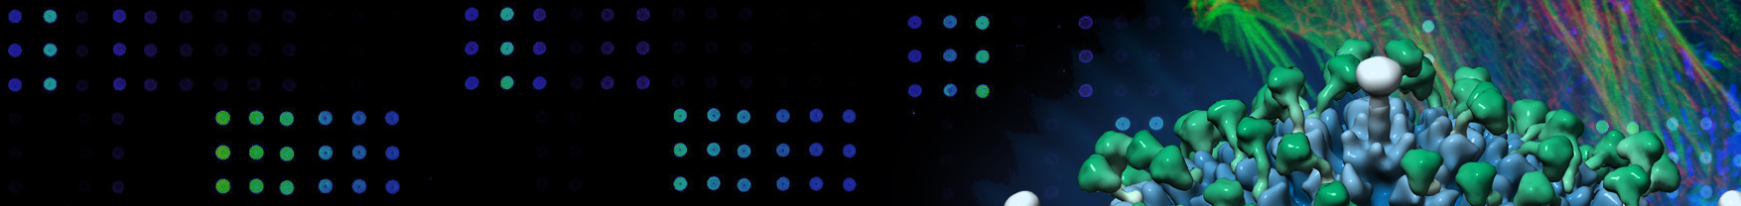
24th Glasgow Virology Workshop
Friday 7th June 2019, Sir Charles Wilson Building, University of Glasgow.

Richard M Elliott memorial lecture
Stuart Neil, King’s College London

Silke Stertz, University of Zürich

Daniel Bausch, Public Health England/ London School of Hygiene & Tropical Medicine

Gill Elliott, University of Surrey

Ann Palmenberg, University of Wisconsin-Madison

Full programme: https://www.gla.ac.uk/researchinstitutes/iii/cvr/events/virologyworkshop/

Standard registration fee of £50 (includes lunch and refreshments). Postgraduate student registration fee £25, undergraduate student registration free. There will also be a Ceilidh following the workshop at 7.30pm in the Glasgow University Union (Dining room). Tickets cost of £10/person (children free) and can be ordered below. REGISTERATION DEALINE: Monday 3rd June 2019

Title: Full Name:
Organisation (to appear on name badge):
Work address:
Email address:
Special dietary requirements:

STUDENTS: (Please tick below √):
Undergraduate: Postgraduate: Undergraduate:
Matriculation # (UoG students only):
Student status: UK EU Other

I wish to attend the CVR Ceilidh : # Ceilidh tickets required (£10/ticket):

PAYMENT: (Please tick below √)
Attendee: £50 Postgraduate: £25 Undergraduate: Exempt
Credit card or invoice payment requests to Evelyn McIntosh (Evelyn.McIntosh@glasgow.ac.uk) referencing GVW in the subject header. Cheques should be made payable to “University of Glasgow” and accompany your registration. We cannot accept cash.

University of Glasgow personnel may pay by indicating their Agresso Sub-project Code to be charged:

Sub-project Code: Budget Holder’s Name:

POST to: Glasgow Virology Workshop, Anne Catchpole, MRC-University of Glasgow Centre for Virus Research, Sir Michael Stoker Building, 464 Bearsden Road, GLASGOW, G61 1QH.

Queries and Email registrations to: cvr-gvw@glasgow.ac.uk

